1)
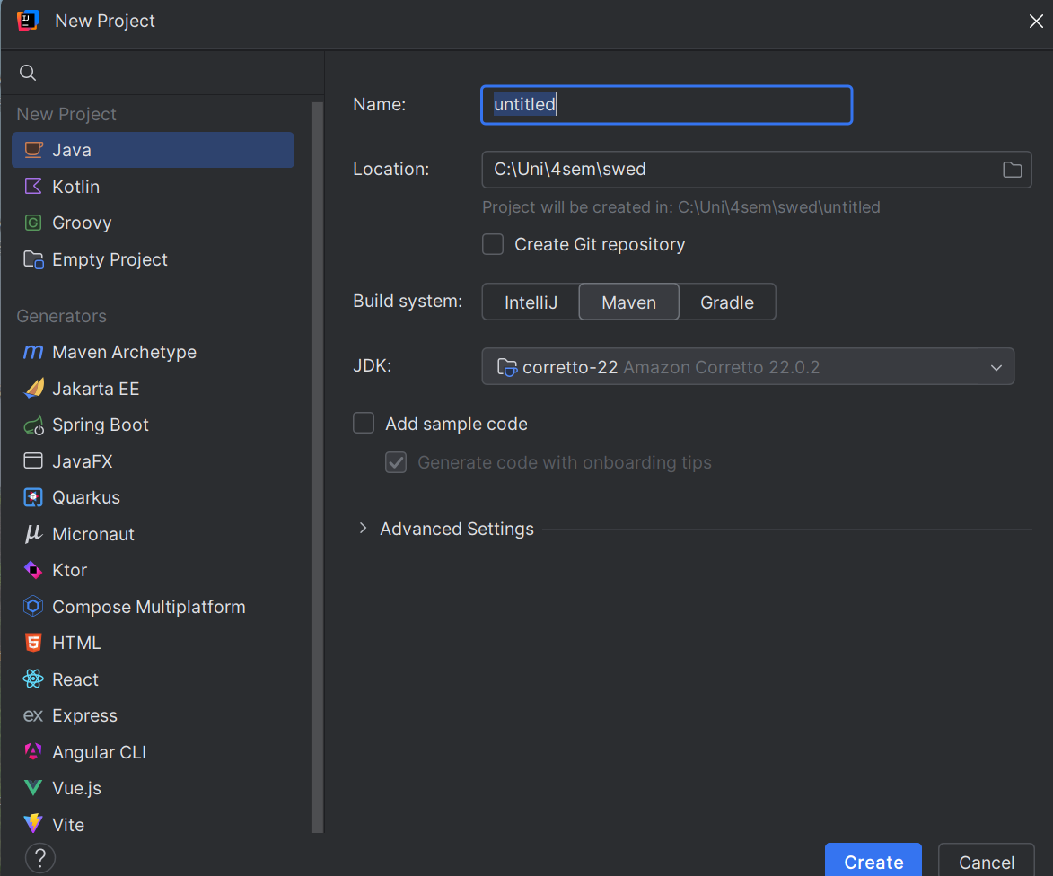

Benefits of ide to text editor:
- Code autocompletion
- Syntax highlighting
- Debugging Tools (such as breakpoints and others)
- integrated compiler/interpreter
- integrated git
- code refactoring (renaming, extracting)
- real time error detection
- easier project management
- code navigation for larger projects
- easy plugins
4)

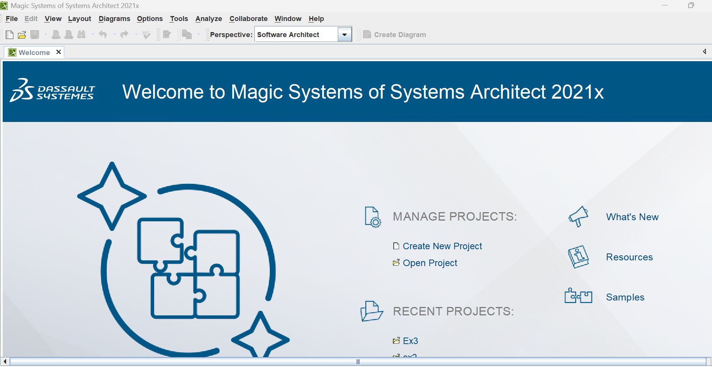

6)
The result of the process of defining the architecture, components, interfaces
and other characteristics of a system or component

Software Design is the process of planning and defining the structure, components, interfaces, and data for a software system to satisfy requirements specified in the analysis phase. It focuses on how the system will be built.
Software Analysis involves understanding, gathering, and documenting the software requirements. Software analysis focuses on what the system must do. It identifies user or client needs.
7)
Software design provides a clear plan for building the software. Without a design phase developers might misunderstand requirements. A good design makes organization and communication much easier and saves time and cost because less mistakes will be made
Projects without this step might work as well but will be a lot harder to maintain and scale. So for long term projects a design phase is always a good idea.
8)
All these design activities are interdependent as for example the components need access to the database and the user interface might need access to the components. If one is changed the others might need to be changed too.

